Third Grade 2024-2025 School Year
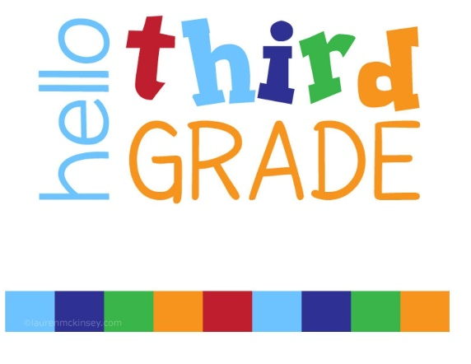
- Expo markers (dry erase)- 1 package of 4-fine tip
- 1 Dry Erase Board, 9” x 12”, unlined
- #2 pre-sharpened Ticonderoga yellow pencil packs (no foil pencils )- 2 boxes
- 4- two pocket plastic folders with Brads (Red, Green, Blue, Orange)
- 4 composition notebooks
- 4 pink erasers
- 4 Highlighters, Yellow, Thick tip
- 3 large glue sticks (no liquid glue)
- 1 pencil pouch
- 1 box of colored pencils
- 1 box of Crayons
- 1 pair of scissors
- 3 containers of Clorox wipes
- 4 Kleenex tissues boxes
- 1 Box Gallon Zipper Bags, 25 ct.
- 1 Box Sandwich Zipper Bags, 25 ct.
- 3 Bottles of Hand Sanitizer
- Headphones/earbuds (no Bluetooth)

